**Stuck On a Word?**

**Think: “What makes sense?”**

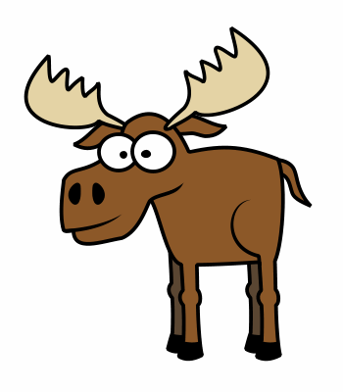 - Use the words

- Use the pictures

**Look at the pictures**

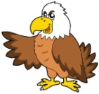- Look for clues in the pictures

**Look at the beginning letters**

* Get your lips ready
* 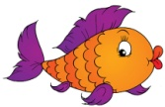Say the first sounds
* What might come next?

**Tap it out/Sound it out**

* Stretch the word out
* 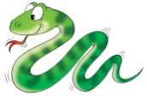Blend the sounds

**Look for chunks**

* Look for word parts
* 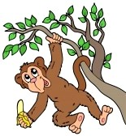Look for smaller words
* **Slide it down your arm**

**Guess and match**

* Make a good guess
* 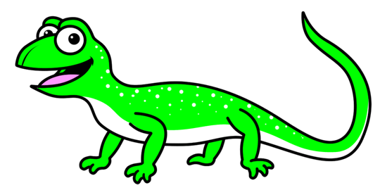Then match it to the letters on the page

**Read on and go back**

* Skip it! Skip the word
* 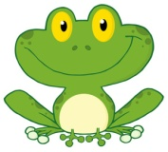Read to the end
* Hop back to read it

**Try all the sounds**

* Try the word again using other possible sounds
* Vowels, y, c, g, s

**Do a cross check**

* Does it look right?
* 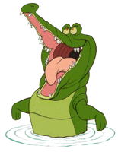Does it sound right?
* Does it make sense?

**Reread to self-correct**

* 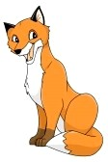When something isn’t right, go back and read it again
* Fix your mistake

**Never let the word win!**

**Try, try again!**

**Stuck On a Word?**

**Think: “What makes sense?”**

 - Use the words

- Use the pictures

**Look at the pictures**

- Look for clues in the pictures

**Look at the beginning letters**

* Get your lips ready
* Say the first sounds
* What might come next?

**Tap it out/Sound it out**

* Stretch the word out
* Blend the sounds

**Look for chunks**

* Look for word parts
* Look for smaller words
* **Slide it down your arm**

**Guess and match**

* Make a good guess
* Then match it to the letters on the page

**Read on and go back**

* Skip it! Skip the word
* Read to the end
* Hop back to read it

**Try all the sounds**

* Try the word again using other possible sounds
* Vowels, y, c, g, s

**Do a cross check**

* Does it look right?
* Does it sound right?
* Does it make sense?

**Reread to self-correct**

* When something isn’t right, go back and read it again
* Fix your mistake

**Never let the word win!**

**Try, try again!**

**Stuck On a Word?**

**Think: “What makes sense?”**

 - Use the words

- Use the pictures

**Look at the pictures**

- Look for clues in the pictures

**Look at the beginning letters**

* Get your lips ready
* Say the first sounds
* What might come next?

**Tap it out/Sound it out**

* Stretch the word out
* Blend the sounds

**Look for chunks**

* Look for word parts
* Look for smaller words
* **Slide it down your arm**

**Guess and match**

* Make a good guess
* Then match it to the letters on the page

**Read on and go back**

* Skip it! Skip the word
* Read to the end
* Hop back to read it

**Try all the sounds**

* Try the word again using other possible sounds
* Vowels, y, c, g, s

**Do a cross check**

* Does it look right?
* Does it sound right?
* Does it make sense?

**Reread to self-correct**

* When something isn’t right, go back and read it again
* Fix your mistake

**Never let the word win!**

**Try, try again!**

**Make Sense Moose**



**Eagle Eyes**

**Lips the Fish**

**Stretchy Snake**



**Chunky Monkey**

**Letter McLizard**



**Skippy Frog**

**Tryin’ Lion**

**Criss Cross Crock**

**Fix-It Fox**

